Outline
Introduction + Business Values + Exec Summary:(March 27(Documentation))
Business Case
Hate Speech Data on social media and company website
Business Value and impact

Data Introduction + data cleansing + Preprocessing(Optional) + data augmentation: Atsu, Hafriza
(March 14(Code), March 20(Documentation))
Data Description
Preprocessing
Data Summary
Text Preprocessing technique
- Tokenization
- Case Normalization
- Spell Checking + Spelling Normalization
- Stop word removal + remove non-ascii character
- Pruning Rare and Common Words
- Removing Patterns
- Stemming and Lemmatization
- Etc.
Handling Class Imbalance
Visualization: Word cloud of the dataset, distribution of text length, etc.
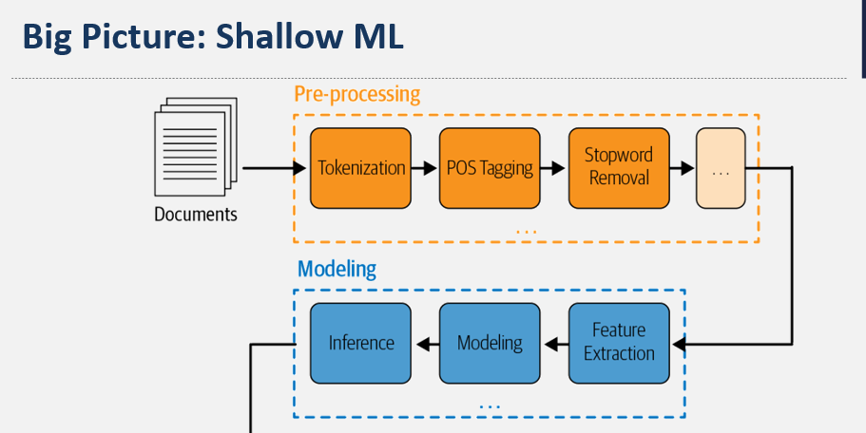
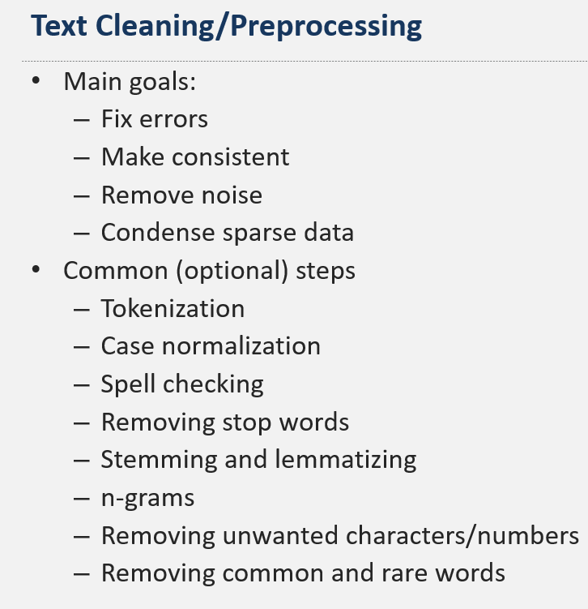
https://github.com/stepthom/NLP_course/blob/main/preprocessing/slides_preprocessing.ipynb

Albert Model Design: Hafriza, Jason
(March 19(Code), March 24(Documentation))
General Design
Framework Selection (Python NLTK, Keras, Pytorch, etc.)
Word Embedding introduction: (Word2vec, Glove, etc.)
Document Embedding
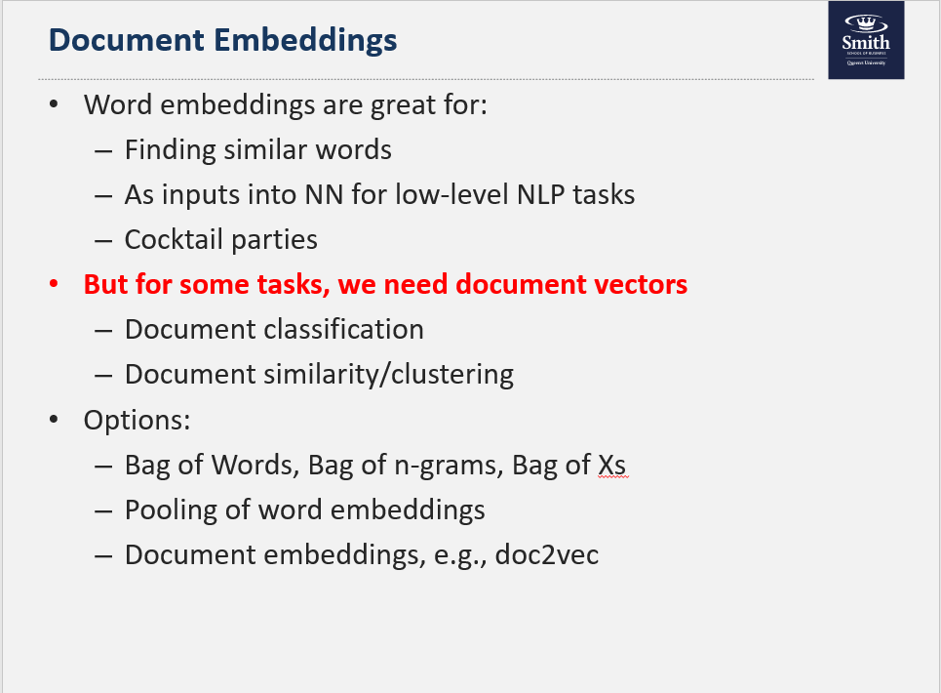
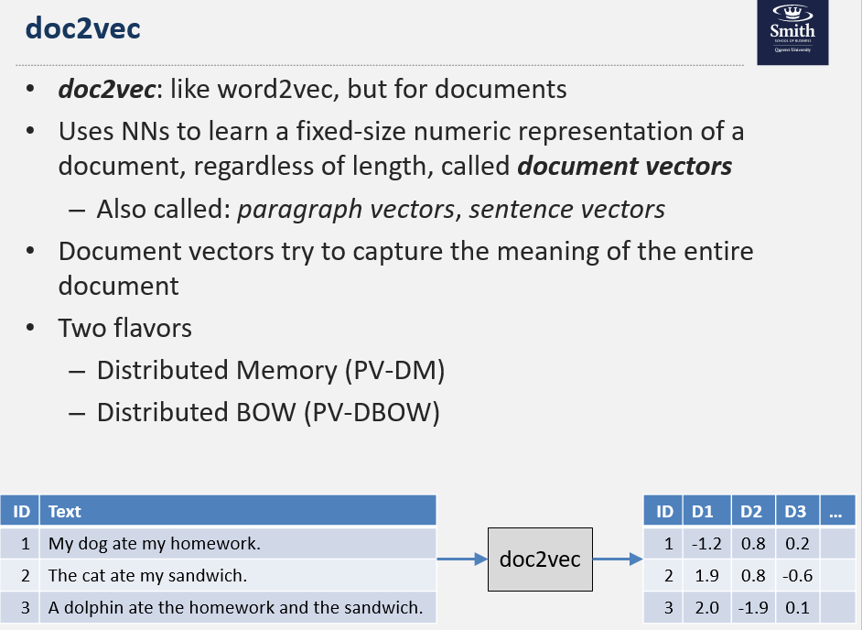
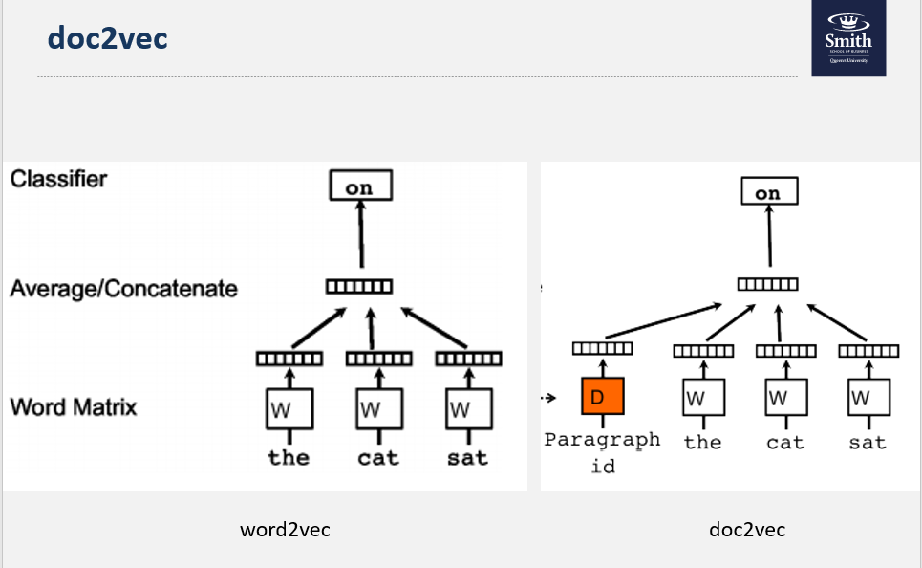
Vectorization
Model (LSTM, CNN, RNN, DNN, GRU) or ensemble with Rule-based
Modeling Architecture
Performance Metric Selection (F1, Accuracy, recall, precision?)
Hyper-parameter selection and other parameters and explanation
Visualization: Albert Model Architecture
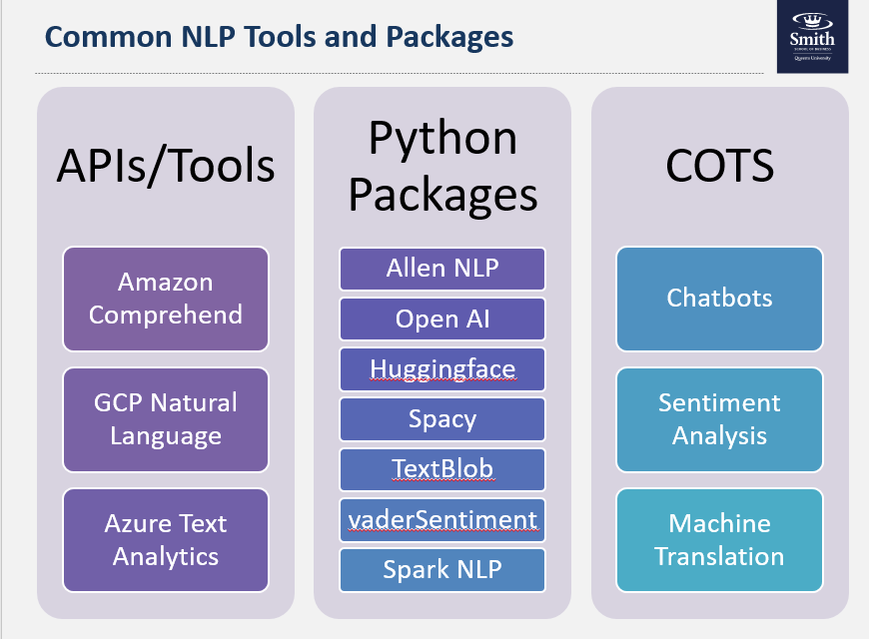
- Python packages
  - NLTK
  - Spacy
  - Gensim
  - Textblob
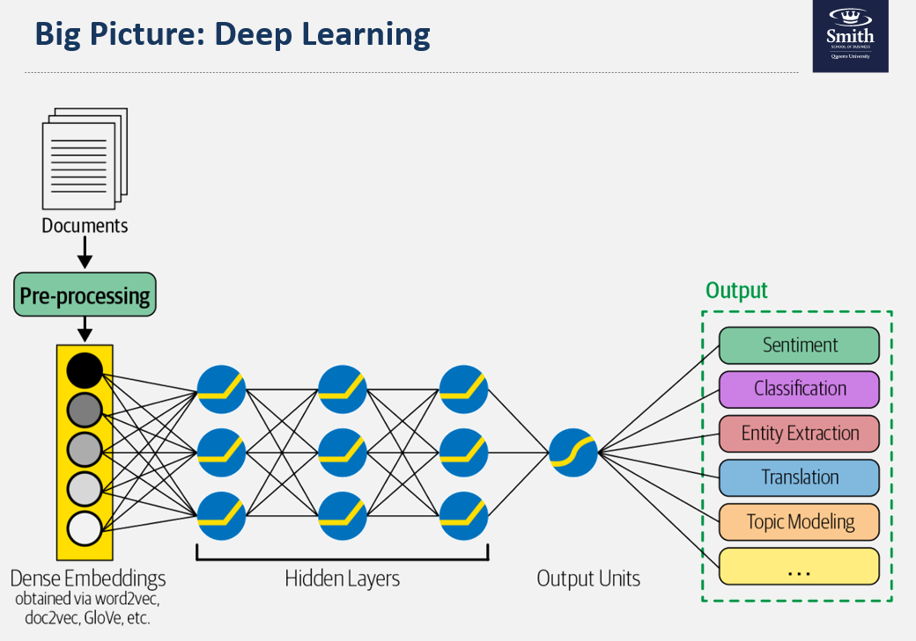

Transfer Learning Jason, Ajay
(March 19(Code), March 24(Documentation))
Pre-trained neural networks
? word embeddings (Word2vec, Glove, etc.)
Pretrained: BERT, ElMo, GPT-2, GPT-3
What is their architecture?
Visualization: Transfer learning model Architecture


Experimentation and Model Comparison: Ajay
(March 19(Code), March 24(Documentation))
Hyper-parameter and Miscellaneous Tuning
Addressing Biases and Overfitting
Albert model Training and Validation
Transfer Learning Training and Validation
Performance Comparison
Model Selection for Deployment
Visualization: Training epochs with accuracy, summary of model performance

Ideas: Lime? SHAP Values?
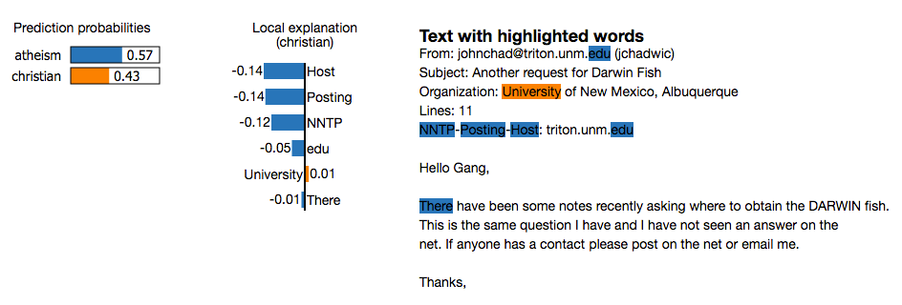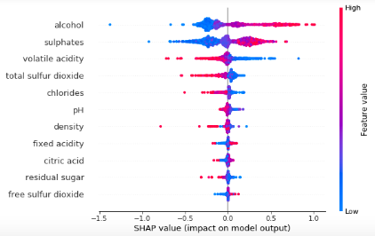

Implementation with Github: Ben
(March 27(Documentation))
GitHub Repository [Bonus]
High Level Description of Code
Required Packages
Implementation Instructions [ Github Readme]
Visualization: GitHub Readme Snapshot

Recommendation and Model Production
(March 27(Documentation))
Model’s Effectiveness for Business Use Case basing on metric
Business Recommendations
Extension to Production
Challenges before Operationalization, and Solutions
Approaches to Operationalization and Scaling

Future consideration and challenges
(March 27(Documentation))
Future Considerations
Dataset Challenges
Processing Power
Other limitation
Privacy issue?

Challenges:
Managing environments: Backwards compatibility, Libraries, modules, dependencies, Load balancing
Serving Models: A/B testing, Storing, updating, Versioning, lineage
Monitoring: Input drift, Output/performance drift
Scheduling: Retraining, Batch jobs

References and Appendix (March 31(Documentation))
Links
Appendix

